Bridging the Gap
Integrated Referrals to Community Pharmacy

Implementation Support Pack

produced in conjunction with

CONTENTS
- Overall aims
- Methods of implementation
- Costs
- Efficiency savings
- Implementation process
- Determining the information to be sent
- Determining which patients to include
- IT considerations
- Information governance considerations
- Standard operating model
- AHSN research proposal and trust action needed
- Staff training
- Community pharmacy engagement
- Formal sign-offs for go-live
- Contact information

APPENDICES WITHIN THIS DOCUMENT
- Appendices
- Appendix 1 - Example Patient Leaflet
- Appendix 2 - Example information transfer service flowchart
- Appendix 3 - Example transfer information in PharmOutcomes
- Appendix 4 - Example Community pharmacist perspective
- Appendix 5 – Transfer of Care Project Plan Template

LINKED APPENDICES
- Appendix 6 Example Community Pharmacy Referrals - Guidelines for Pharmacists
- Appendix 7 Example Community Pharmacy Referrals – Information for Patients Leaflet
- Appendix 8 PharmOutcomes Procedure for Amending a referral to Community Pharmacy
- Appendix 9 PharmOutcomes Procedure for Cancelling a Referral to Community Pharmacy
- Appendix 10 Procedure to follow in the event of PharmOutcomes downtime
- Appendix 11 PharmOutcomes Procedure for entering a referral to community pharmacy

Introduction
NHS England Cheshire and Merseyside and the North West Academic Health Science Network are supporting a project to implement referrals from hospital pharmacy to community pharmacy as patients move between settings.
This paper provides background information to support the implementation.

Overall aims
People who take medicines for long term conditions often have changes made to their usual prescription during a stay in hospital. Evidence shows that problems with medicines can arise during clinical handover from secondary care to primary care. This can sometimes be the cause of patients being readmitted. Community pharmacy can help address this problem if they have accurate and timely information.
The overall aims of the project are therefore:
- to improve patient care through the better provision of information to community pharmacy;
- to improve patient care through the subsequent provision of follow-up information to GPs, referrers and others as appropriate; and
- to generate efficiency savings for Hospital Trusts and CCGs, primarily through a reduction in the number of avoidable bed days.
It is worth noting that community pharmacies do not benefit financially from this project. They are limited for payment purposes to providing 400 medicine use reviews (MURs) per annum and there is no additional funding for exceeding this number. The majority of community pharmacies are already providing this maximum number of MURs.
Evidence from implementations elsewhere however shows that the transfer of information to community pharmacies enables them to target these MURs more usefully and many pharmacies report significant improvements in their ability to provide higher quality care as a result of discharge information provided.

Methods of implementation
There are three methods of implementing information transfer using PharmOutcomes.
Full electronic integration | The only additional work for pharmacists required at the referrer end is the input of choice of receiving pharmacy. All other information is picked up electronically from existing data held within the hospital systems.
Partial electronic integration | This approach pulls some information (typically demographic and medicines data) from the hospital PAS system and feeds it electronically into a PharmOutcomes template. Other information, for example action required, is then entered manually into the PharmOutcomes record using a web browser.
Manual data entry via web portal | This solution uses a web based interface. Referring pharmacists enter basic demographic information and other data as required via a web browser and the data is passed to community pharmacy. The solution is suitable for those trusts where prescribing information is currently recorded in paper systems.

Regardless of the type of solution, the same information can be supplied to community pharmacy. In some instances of partial integration or manual data entry, this may be in the form of pdf attachments rather than electronically structured data but this is determined by local referrer practices.

Costs
There are two sets of costs associated with implementing the electronic transfer of information to community pharmacy:
Community pharmacy end | Community pharmacies need access to the PharmOutcomes system in order to be able to follow-up on referrals. For integrated solutions the cost of follow up is covered by Pinnacle Health as part of that licence cost, for those sites using the web solution, NHS England North West have bought an area licence covering this and are committed to paying for this for the foreseeable future as this also provides other benefits such as the ability to receive NUMSAS referrals from NHS 111. There is therefore no cost for this to referrers provided the relevant follow-up footprint is covered.
Referrer end | NHS England North West are paying the first year licence costs for all referrers in their area and all hospitals will be able to transfer data to community pharmacy free of charge during this period. This will enable Trusts to evaluate the benefits of the approach and to decide whether they want a licence in future years.  The licence cost for all solutions is £3,995 + VAT for the first system integration for an NHS Trust hospital site to cover a follow-up footprint of up to 1,000 community pharmacies.  If an NHS Trust operates as a Partnership Trust and has an additional site managed by the same IT team, then adding a second referring system for additional sites is a reduced £995 + VAT to cover a follow-up footprint of up to 1,000 community pharmacies.

Efficiency savings
In addition to improving outcomes for patients, one of the key drivers for the project is to deliver financial savings for Trusts and CCGs by reducing the number of avoidable bed stays. Although these could be realised as cash releasing savings, in practice it is more likely that the available bed days released will be used in the form of additional capacity which would otherwise not be available.
The expectation for the savings is derived from an independent study carried out by Durham University on two Newcastle hospitals and subsequently published by in the BMJOpen.
In the Newcastle implementation, hospitals referred a limited selection of patients (those on multiple medications) to community pharmacies on discharge. Of these, 36% were followed up by pharmacies. Even with this limited level of follow-up, it was estimated that follow-up activity such as medicine use reviews led to savings of:
- £623,115 pa for the hospital trust
- £734,801 pa for the CCG
These savings derive from current funding models which require Trusts to pick up the costs of readmissions within thirty days and the CCG to pick up the cost of readmissions between thirty and ninety days.
Recent data demonstrates that the follow-up rates for referrals passed to community pharmacy for Newcastle and elsewhere are now in excess of 70%. This suggests that the above savings, based on referrals of 1386 patients over the course of the initiative, are likely to be understated.
The AHSN has commissioned researchers to carry out a cost / benefit analysis of the current project and this information will be made available to enable Trusts to decide whether to continue with the project after the first year of funding ends.
In the meantime, NHS England North West has calculated on the basis of the Durham study that each targeted referral to community pharmacy can lead to 0.8 bed days saved. Trusts can make an estimate of likely savings in bed day costs from the project using this figure and their current discharge rates.

Implementation process
There are a number of stages that need to be followed once a Trust has committed to implementing the PharmOutcomes solution.
Determine and confirm the method of implementing | This will usually be full electronic integration if the information is currently available in electronic format and the hospital is already sending electronic discharge information to GPs. | Trust
Determine the patient sets to be included. | The Trust will need to decide whether to refer all or selected discharges to community pharmacy. Some Trusts have indicated they would like to start with a particular subset of patients. Others have indicated they would like to notify all discharges. This choice will need to be reflected in the relevant Standard Operating Procedure. | Trust
Determine the information to be provided to patients | It is useful to provide patients with written information on how the information transfer service will work. An example from South West AHSN is included in the appendices | Trust
Determine the information that the Trust would like to send to community pharmacy | This involves deciding what information to pass across at the point of discharge. It can be restricted to simple demographic data or it can include full information around medicine use, allergies and other clinically relevant data.  PharmOutcomes can transfer whatever information is agreed at the outset of initiative. | Trust
Determine the IT requirements and agree a timescale for implementation and sign off | The only IT requirement for the manual solution is access to a web browser. Integrated solutions require IT support but this is typically only a couple of days work. | Trust with support from Pinnacle
Determine the information governance requirements and agree a timescale for clarification and sign-off | There are information governance requirements around the sharing of information and consent which need to be considered locally. A Privacy Impact Assessment may be needed. | Trust with support from Pinnacle
Develop a standard operating procedure and the behaviour changes required. | This involves developing a standard operating procedure which meets local requirements, fits with local information governance and consent practice and is aligned to the technical solution to be implemented. | Trust
Develop and test message transport processes | For manual and partial solutions, this involves customising and testing the web interface to meet local needs.  For fully integrated and partial solutions this involves developing and testing the mapping of data fields to the transport mechanism | Trust / Pinnacle
Review AHSN research proposals and gain sign off locally | The intention as part of the project is to evaluate the benefits of transferring data to community pharmacy. Getting sign off for research will not affect go live but may affect the subsequent use of data for research purposes. | Trust / AHSN
Train staff | Develop and deliver appropriate training | Trust
Communicate with and train community pharmacists | Develop and deliver appropriate communication and training | AHSN / Trust
Formal sign-off by IT lead |  | Trust
Formal sign-off by IG lead |  | Trust
Formal sign-off of data to be provided |  | Trust
Formal sign-off of SOP |  | Trust
Formal sign-off to go live |  | Trust
Formal sign-off of acceptance |  | Trust

Determining the information to be sent
Trusts will need to decide locally which information they want to pass across to community pharmacy. This can be tailored Trust by Trust and site by site.
This can most easily be done by identifying relevant data fields in current IT systems. The following screenshots from PharmOutcomes ‘virtual hospital’ PAS emulator may be useful in thinking about this process. An example in PharmOutcomes format is included in Appendix 3.
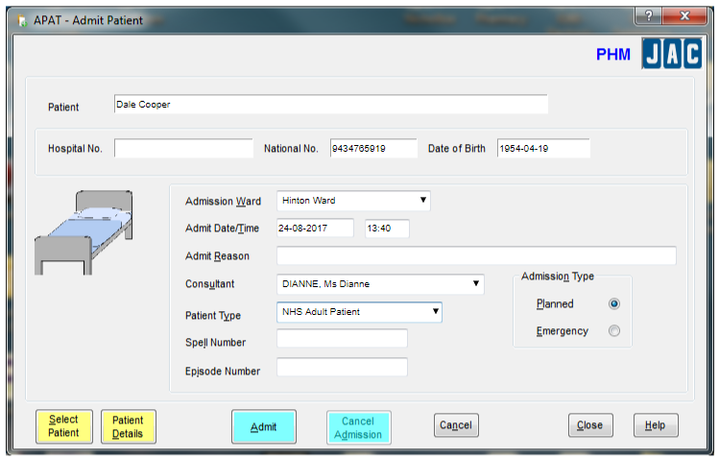 | Relevant details from here might include:  - patient forename  - patient surname  - date of birth  - NHS number  - Ward  - Consultant  - Admission type

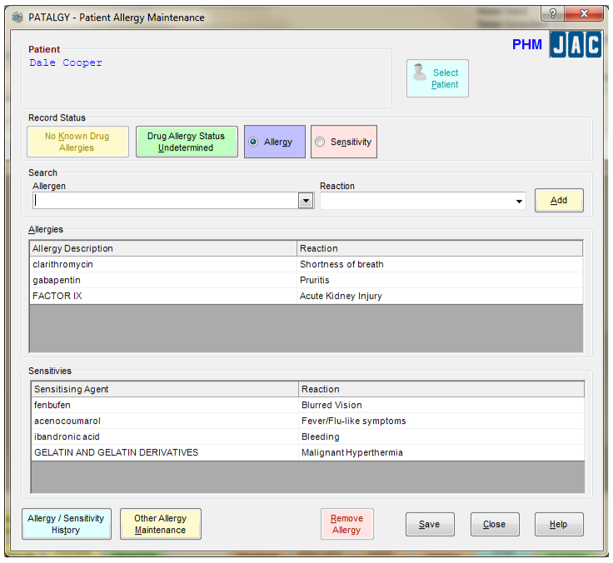 | Relevant details from here might include:  - allergy description  - nature of allergy reaction  - sensitising agent  - nature of reaction to sensitising agent

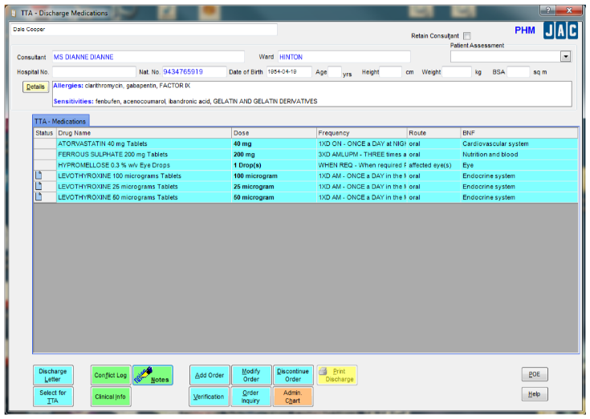 |  | Relevant details from here might include:  - drug name  - dose  - frequency  - route  - continuation
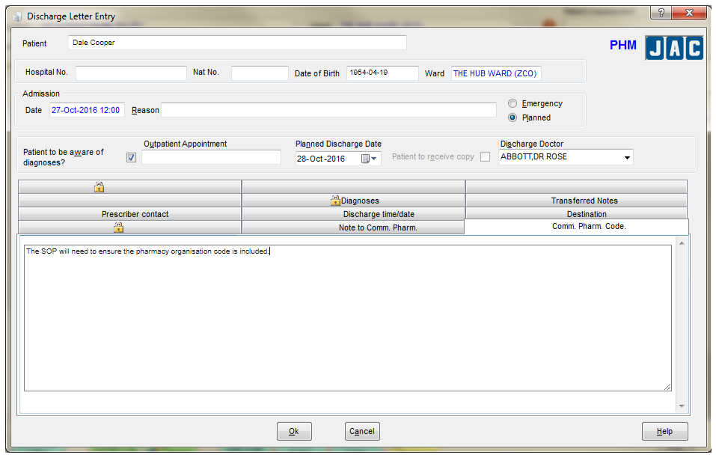 | Relevant details from here might include:  - referral destination  - note to community pharmacy
The discharge information will need to include the organisational (ODS) code for the relevant community pharmacy so that the information can be directed to the correct destination. This is recorded using a dedicated text field within the hospital system. Pinnacle will provide a browser based link as part of the implementation which enables staff to easily look up relevant pharmacy ODS codes.

Determining which patients to include
Some Trusts have indicated that they would like to implement the project by referring a particular subset of patients (for example, patients with multiple and complex medicine requirements, or patients with mental health and particular physical health conditions). Others have indicated they would like to notify all discharges and have undertaken to resource departments appropriately to achieve patient consent for this. Alternatively, Trusts may wish to start off by referring patients from particular wards or on a randomised or risk management basis.

IT considerations
There is no technical work required to use the web version of PharmOutcomes. We will simply provide a nominated person with system log-in details and administration rights. Referrals to community pharmacy can begin as soon as training has been completed.
Trusts requiring full or partial electronic integration should send the following information to our interoperability support service at itk.support@phpartnership.com who can also be contacted by telephone on 01983 216 699
- IT contact name
- Trust / hospital name
- Role within organisation
- Email
- Phone number
- Current PAS system and version
- Current dispensing system and version
- Are you currently sending discharge information electronically to GPs?
- What message broker is currently in use at the Trust
- What message type is sent (e.g. HL7v2, HL7 v3 CDA payload)?
- How would you record the destination pharmacy currently as part of the discharge information?

The Pinnacle team will then share with you one or both of the following documents to allow technical considerations to be reviewed and discussed with the Trust technical team:
- HL7 v2 Message Specification for PharmOutcomes
- CDA Message Specification for PharmOutcomes

It is not possible to predefine the work required here as this varies by PAS and EDS, message brokering system, security mechanisms and other factors.
Experience elsewhere however has indicated that allowing 2-3 days at the Trust end for understanding, implementing and testing the messaging process is a realistic expectation of workload.

Information governance considerations
There are a number of information governance considerations which need to be taken into account in transmitting information across to Community Pharmacies.
Pinnacle Health Partnership LLP, the suppliers of PharmOutcomes, have already assured NHS England North West and the North West Academic Health Science Network of its ability to meet all of the relevant legislative and best practice requirements in relation to this. Individual Trusts are however welcome to speak to Pam Bowes (pam.bowes@phpartnership.com or 01983 216699), partner and governance lead at Pinnacle if they have any queries.
Frequently Asked Questions
What governance arrangements does Pinnacle Health have in place? | Pinnacle Health:  - has NHS IG Toolkit Level 3 certification  - works within a relevant independently assessed ISO 27001 assurance scheme.  - operates systems in multiple, secure, hardened, data sites.  - actively manages system and network capacity and performance.  - arranges independent security and penetration testing annually and in the event of material infrastructure changes.  - is accredited as fully compliant with CyberEssentials Plus.  - stores and processes all data entirely within the UK.  - encrypts all data using 256 bit AES where possible.  - trains and updates all staff on IG usually monthly and at least quarterly.  - carries out business continuity tests quarterly.  - carries out regular privacy impact assessments.  - actively monitors information governance at board meetings on a monthly basis.  Our full Technical and IG Specification is available here
Does Pinnacle comply with the EU GDPR? | The EU General Data Protection Regulation has already been accepted in to UK law and comes in to force in May 2018. Pinnacle has a qualified GDPR practitioner as its governance lead and the company is currently updating processes, documentation, contracts and agreements as necessary to ensure full compliance by the launch date.
Who are the data controllers | In the case of hospital discharge referrals, there are three data controllers under the legislation:  - NHS North West who buy the PharmOutcomes licence;  - hospital trusts who decide what data is to be provided; and  - community pharmacists who carry out follow up activity.  Pinnacle Health acts as a data processor on behalf of all three.
How does Pinnacle comply with data retention obligations and Goddard? | Pinnacle complies fully with NHS data retention requirements.  The Goddard enquiry stated that any records which may be required as part of a sexual abuse case should not be deleted until the enquiry is completed. This includes health records and Pinnacle is compliant with this requirement.
Can commissioners see referral and follow-up information? | Commissioners can see referral and follow up information in anonymised or pseudo-anonymised format as appropriate. Commissioners can only see patient identifiable information under very specific conditions with full governance and access controls to named individuals on signed explanation and declaration.
Do Trusts need to do a privacy impact assessment? | Trusts will need to be confident that patients have given appropriate consent for information to be passed to community pharmacy on discharge unless relying on healthcare legislation which allows this in the patient’s best interest.  Processes for obtaining consent for sharing information at the community pharmacy end are built in to the PharmOutcomes system.
Can we arrange for other Trusts to copy us in on discharge to community pharmacy? | This FAQ arose within the context of a Mental Health Trust which would find it useful to know about discharges from Acute Trusts for some patients. This is technically possible within the PharmOutcomes environment with a small amount of development provided that the source system can record the additional destination on discharge and provided that all information governance considerations have been considered within the SOP.
Can Trusts receive a bespoke notification from community pharmacies after follow-up? | This FAQ also arose in the context of a Mental Health trust which would welcome updates from community pharmacists. This is easily possible within the PharmOutcomes system provided the Trust has a secure nhs.net email account that can be used which is appropriately monitored and actioned.

Formal sign-offs for go-live
Sign-off processes vary on a Trust by Trust basis but the following are likely to be required. It is recommended that each Trust defines the persons responsible at the start of the project and is kept involved / informed throughout.
Area | Declaration | Name | Date | Signed
Message content | I declare that the content of discharge messages to be sent to community pharmacy has been properly identified, considered and approved and that the project can go live once all other areas are signed off.
Standard Operating Procedure | I declare that the Trust has determined the way it wants to send discharge referrals to community pharmacy, developed a robust supporting operating procedure and trained all relevant staff. I declare that the project can go live once all other areas are signed off.
IT | I declare that all IT related work required to implement discharge referrals to community pharmacy, including associated security and IT governance work, has now been completed and that the project can go live once all other areas are signed off.
IG | I declare that all information governance work required to ensure the safe launch and operation of discharge referrals to community pharmacy has now been completed and that the project can go live once all other areas are signed off.
Go Live | I agree that all preparatory work for implementing discharge referrals to pharmacy has been reported as being completed to a satisfactory standard and agree that the project can go live.
Project Close | I agree that all evaluation work following go live of discharge referrals to community pharmacy has been completed to an acceptable standard. Lessons learned have been reported to the AHSN and follow up actions have been agreed as necessary. I agree the project can be closed for this Trust.

Contact information

Innovation Agency Programme lead | andrew.shakeshaft@innovationagencynwc.nhs.uk
NHS England project support | hassan.argomandkhah@nhs.net  brucie.p@btinternet.com

Pinnacle Health LLP IT support | ricky.oswald@phpartnership.com
Pinnacle Health LLP information governance | pam.bowes@phpartnership.com
Pinnacle Health pharmacist support | kevin.noble@phpartnership.com

more information on the Newcastle Study | hamde.nazar@durham.ac.uk
more information on the economic evaluation | gary.warner@phpartnership.com
more information on the PharmOutcomes solutions | pst@phpartnership.com

Appendices
Within this document
Appendix 1 Example Patient Leaflet
Appendix 2 Example information transfer service flowchart
Appendix 3 Example transfer information in PharmOutcomes
Appendix 4 Example community pharmacist perspective in PharmOutcomes
Appendix 5 Template project plan

External links
If the links below do not work directly,
- please go to http://bridgethegap.pharmoutcomes.org
- enter the relevant contact details - this will help us with the implementation
- click the download button
This will download an up-to-date copy of this paper. You may need to ‘enable’ the document for editing for the links to work.
Appendix 6 Example Community Pharmacy Referrals - Guidelines for Pharmacists
Appendix 7 Example Community Pharmacy Referrals – Information for Patients Leaflet
Appendix 8 PharmOutcomes Procedure for Amending a referral to Community Pharmacy
Appendix 9 PharmOutcomes Procedure for Cancelling a Referral to Community Pharmacy
Appendix 10 Procedure to follow in the event of PharmOutcomes downtime
Appendix 11 PharmOutcomes Procedure for entering a referral to community pharmacy

Appendix 1 - Example Patient Leaflet
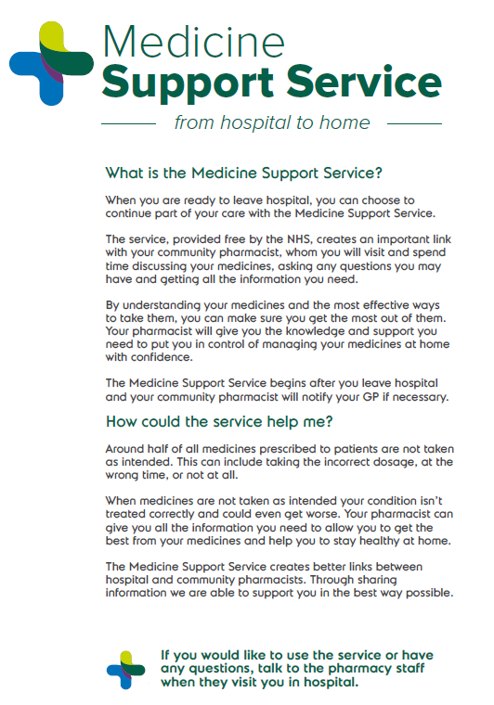
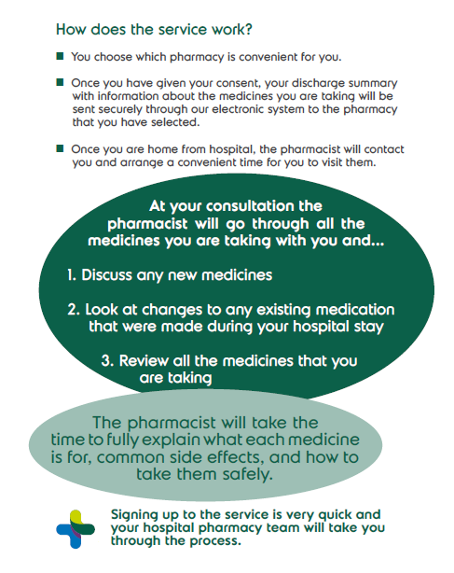

Appendix 2 - Example information transfer service flowchart
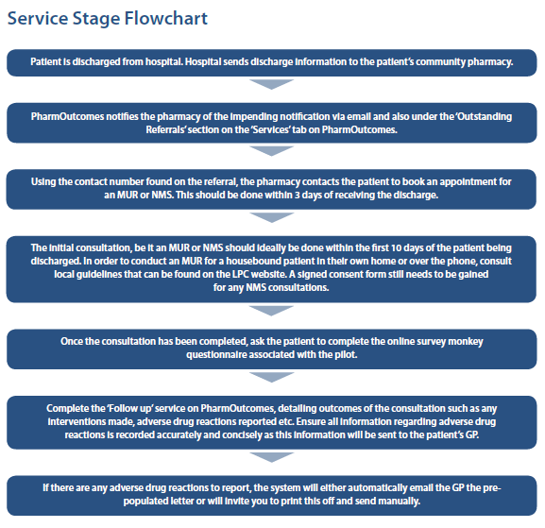

Appendix 3 - Example transfer information in PharmOutcomes
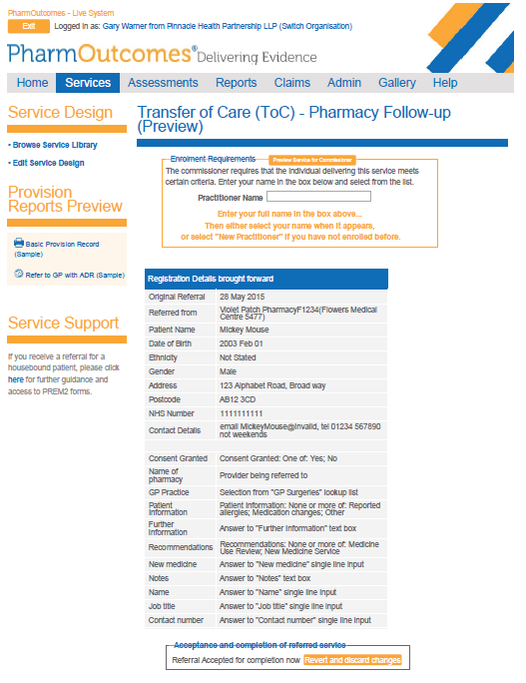

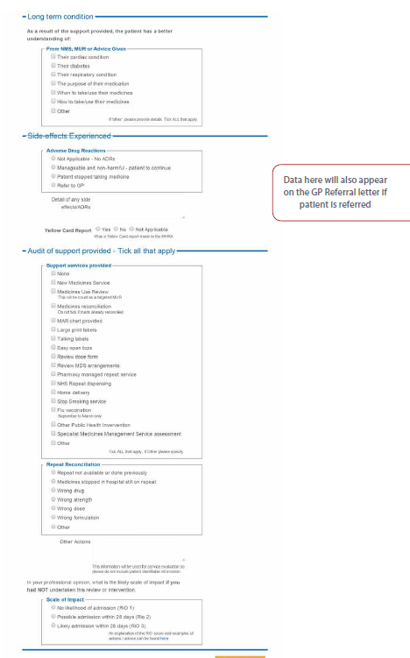

Appendix 4 - Example Community pharmacist perspective
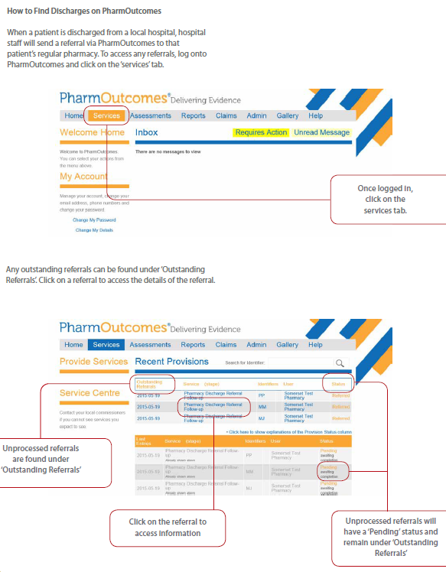

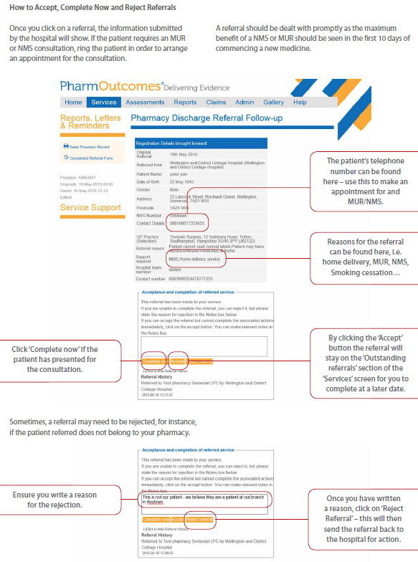

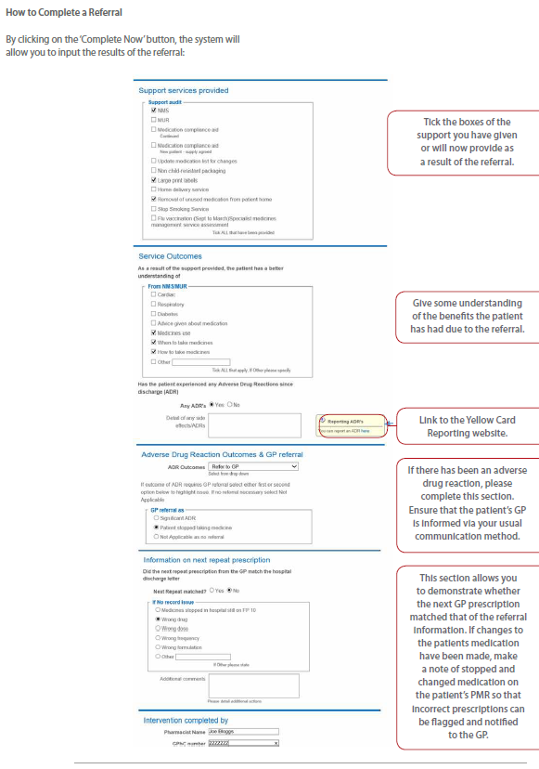
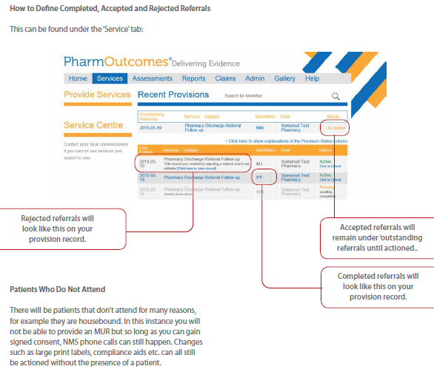

Appendix 5 – Transfer of Care Project Plan Template
Category | Task | Start | End | Owner
Project Initiation | Identify Trust project lead |  |  | AHSN
 | Identify Trust IT lead |  |  | AHSN
 | Identify Trust Governance lead |  |  | AHSN
 | Identify Trust person responsible for SOP |  |  | AHSN
 | Identify Trust lead for research approvals |  |  | AHSN
 | Identify Trust person to approve go-live |  |  | AHSN
 | SLA in place between Pinnacle and Trust (Available Here) |  |  | Pinnacle/Trust
Project Start Up | Determine full, partial or manual approach |  |  | Trust
 | Develop draft project plan with timescales and responsibilities |  |  | AHSN/Trust
 | Confirm approach, responsibilities and timescales with Trust leads |  |  | AHSN/Trust
 | Confirm approach and target launch date with person to approve go-live |  |  | AHSN/Trust
Determine patients and information to be included in transfers | Decide and document which information to be passed across |  |  | Trust
 | Advise IT lead of information fields to be passed across (unless manual) |  |  | Trust
 | Decide which patients (all or groups) to be included and how phased |  |  | Trust
 | Develop standard operating procedure |  |  | Trust
 | Identify and document staff to be trained. |  |  | Trust
 | Develop training session and supporting information packs for staff |  |  | Trust
 | Develop supporting information material for patients |  |  | Trust
 | Schedule dates for training including rooms etc. |  |  | Trust
 | Standard operating procedure and training plans complete |  |  | Trust
 | Ready for go-live approved by SOP lead (MS) |  |  | Trust
IT Requirements | FOLLOWING ONLY NEEDED FOR FULL OR PARTIAL ELECTRONIC INTEGRATION
 | Trust Preparation
 | IT lead to identify if currently sending discharge information electronically to GPs |  |  | Trust
 | IT lead to identify current message type in use (HL7v2, HL7v3 CPA payload, other) |  |  | Trust
 | IT lead to determine transport type (HTTPS or MLLPS with TLS MA) |  |  | Trust
 | IT lead to identify current PAS system |  |  | Trust
 | IT lead to identify current dispensing system |  |  | Trust
 | IT lead to contact Ricky Oswald at Pinnacle |  |  | Trust
 | Messaging Activity
 | Ricky to forward relevant message specification to IT lead |  |  | Pinnacle
 | Trust to configure message with required information content (incl. means of adding pharmacy ODS code) |  |  | Trust
 | Set Up Activity
 | Pinnacle to add Trust to 7Bridge for routing/transport |  |  | Pinnacle
 | Pinnacle to complete 7Bridge integration documentation |  |  | Pinnacle
 | Pinnacle to create new commissioning area if required |  |  | Pinnacle
 | Pinnacle to create SysAdmin user if new area |  |  | Pinnacle
 | Pinnacle to create Commissioner primary user, if new area |  |  | Pinnacle
 | Pinnacle to determine and add pharmacies to follow-up footprint |  |  | Pinnacle
 | Pinnacle to import Discharge Referral service from super user page |  |  | Pinnacle
 | Pinnacle to connect referral service ITK fields |  |  | Pinnacle
 | Pinnacle to add hospital as a provider with their ODS code |  |  | Pinnacle
 | Pinnacle to create user in the hospital called “dispensary.system” and grant service provision rights |  |  | Pinnacle
 | Pinnacle to create a hospital super user for support use |  |  | Pinnacle
 | Pinnacle to create a primary user for the Trust clinical/technical team |  |  | Pinnacle
 | Pinnacle to create appropriate users at the Trust as advised by the IT lead |  |  | Pinnacle
 | Pinnacle to accredit the hospital for the referral service |  |  | Pinnacle
 | Pinnacle to accredit all relevant community pharmacies for the follow-up service |  |  | Pinnacle
 | Pinnacle to add the interoperability mapping for the Trust |  |  | Pinnacle
 | Pinnacle to complete all supporting technical documentation |  |  | Pinnacle
 | Testing and Fine Tuning
 | Send and receive test messages and validate for accuracy. |  |  | Trust/ Pinn
 | Refine the data set with the clinical team until correct. |  |  | Trust/ Pinn
 | Discharge messages with all relevant content being sent accurately (MS) |  |  | Trust/ Pinn
 | Pinnacle to document agreed final configuration |  |  | Pinnacle
 | User Support Material
 | Trust to provide any locally required user guides |  |  | Trust
 | Any IT training requirements included in planned training. |  |  | Trust
 | Pinnacle to ensure generic and locally supplied user guides are accessible |  |  | Pinnacle
 | IT Sign-Off
 | Ready for go-live approved in writing by IT lead (MS) |  |  | Trust
Information Governance Requirements | IG lead to identify and document any information governance queries. |  |  | Trust
 | IG lead to send any queries to Pam Bowes at Pinnacle |  |  | Trust
 | Pam to respond to any queries and follow ups until IG lead satisfied. |  |  | Pinnacle
 | Trust Privacy Impact Assessment prepared and approved if required |  |  | Trust
 | SLA with Data Processing Agreement in place with Pinnacle (available here) |  |  | Trust/Pinnacle
 | Any IG training requirements included in planned training |  |  | Trust
 | Ready for go-live approved in writing by IG lead (MS) |  |  | Trust
Research and Evaluation | AHSN to advise Trust lead on research proposals |  |  | AHSN
 | Trust lead to identify any local requirements |  |  | Trust
 | Trust lead to obtain clearance for research from local board and IG as appropriate |  |  | Trust
 | AHSN researcher amends study protocols as required |  |  | AHSN
 | Ready for go-live approved in writing by research lead (MS) |  |  | Trust
Pre Go-Live | Confirm required approvals to progress have been signed-off |  |  | AHSN
 | Agreed start date for live message transfer agreed with Pinnacle |  |  | Trust / Pinn
 | Trust formal GO-LIVE DECISION approved in writing (MS) |  |  | Trust
 | Staff training delivered |  |  | Trust
 | Community pharmacy training delivered |  |  | Trust
 | Trust project lead confirms training delivered and Trust good to go. |  |  | Trust
 | Pinnacle confirms company is ready to start receiving live messages. |  |  | Pinnacle
 | Live transfer of discharge information to community pharmacy begins. (MS) |  |  | Trust / Pinn
Post Go-Live | Pinnacle monitors messaging for transmission errors |  |  | Pinnacle
 | Community pharmacists carry out follow-ups as appropriate |  |  | Com Pharm
 | NHSE, AHSN and Trust monitor reports and activity. |  |  | AHSN
 | Post implementation check between Trust, NHSE and AHSN |  |  | AHSN
 | Trust implementation sign-off recommended in writing by Trust leads. |  |  | Trust
 | TRUST IMPLEMENTATION SIGN-OFF confirmed in writing (MS) |  |  | Trust
 | Evaluation research report completed |  |  | AHSN
 | Evaluation report approved for distribution (MS) |  |  | AHSN
 | PROJECT SIGNED OFF by NHSE (MS) |  |  | NHSE

Audit published by the NHS Specialist Pharmacy Service in August 2016, updated July 2017: https://www.sps.nhs.uk/wp-content/uploads/2015/11/Medicines_Reconciliation_Collaborative_Audit_Report.pdf
Nazar et el, http://bmjopen.bmj.com/content/6/10/e012532.full
Acknowledgements for the leaflet to South West Academic Heath Science Network, Yeovil Hospital and Somerset LPC.

